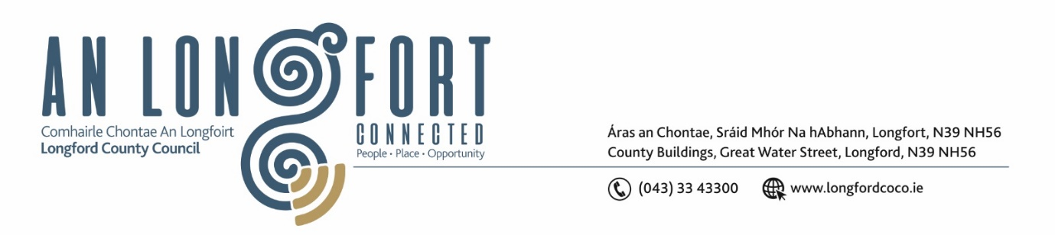

***Please note meeting will be held in the Council Chamber and via Microsoft Teams.***

2 October 2024

**Chuig: Gach Ball don Chomhairle**

A Chomhairleoir,

Iarrtar ort bheith i láthair ag Cruinniú Míosuil Chomhairle Chontae Longfoirt a tionólfar i Seomra na Comhairle, Aras an Chontae, Longford agus via MS Teams are an **Chéadaoin 09 Deireadh Fomhair 2024 ag 4pm** chun gnó a dhéanamh d’réir an Chláir thíos.

You are requested to attend the Monthly Meeting of Longford County Council to be held in the **Council Chamber and via Microsoft Teams** on **Wednesday, 09 October at 4pm** to transact business, as set out on the Agenda hereunder.

Mise le meas,

**__________________**

***Claire McNabola***

***Meetings Administrator***

**C L Á R**

Prayer before meeting.

1. **Confirmation of Minutes**
2. Monthly meeting of Longford County Council held on 11 September 2024 – enclosed.
3. Matters Arising
4. Declaration of Interest by Members
5. To note Management Report
6. To note adopted Minutes of Corporate Policy Group Meeting held on the 10 July 2024 – enclosed.
7. **Housing, Planning, Regeneration & Capital Projects**
8. Consideration of Section 183 – Disposal of 25 Main Street, Longford
9. Consideration of Section 183 – Disposal of 21 Congress Terrace, Longford
10. Consideration of Section 183 – Disposal of 12 Cnoc na Greine, Granard, Co. Longford
11. Draft Traveller Accommodation Plan 2025-2029
12. Consideration of Part 8 – No.121 Playground upgrade, MacEoin Park, Longford
13. Notice of Motions set out hereunder:

**Councillor Paul Ross**

That Longford County Council call on the Minister for Housing, Local Government and Heritage Darragh O’Brien to review the Croi Conaithe Vacant Homes Grant Scheme and introduce phased payments to allow persons draw down the grant in a number of payments

1. **Community, Library and Cultural Services, Corporate Services**
2. Approval to the appointment of Sectoral Representatives to the Strategic Policy Committees.
3. Consideration of the Customer Services Charter
4. Consideration of Revised Protocol - Attendance by Elected Members as Guests at Official Overseas Events
5. **Infrastructure, Climate Action and Innovation**
6. Declaration of Roads to be Public Roads at Templemichael Business Park, Longford
7. **Finance and Information Technology**

**(i)** Consideration of Overdraft Accommodation of €15m for year ending 31 December 2025

1. **General**
2. Notice of Motions set out hereunder:

**Councillor Sean Mimnagh**

I call on Longford County Council to contact the State Exam Commission to include formal accommodations for students who stammer, in the Reasonable Accommodation at Certificate Examinations (Race) guidelines 2025.

1. **Training Approval**
2. **Votes of Sympathy**